Safety Knowledge Sharing
3D printing | September 2023

Description of the incident
At about 14:00 on 14 September 2023, a dust deflagration accident occurred at Shanghai Hanbang Lianhang Laser Science and Technology Co., Ltd (hereinafter referred to as Hanbang), in which the dust deflagrated twice within a short period of time, resulting in the deaths of two persons and serious injuries to two persons (the burnt areas of the seriously injured persons were 90% and 70%, respectively).

The 2 deflagration accidents
- At 11:32, the first deflagration occurred in a cartridge dust collector used in the 3D printing process. The operator immediately extinguished the fire and the deflagration did not spread further.
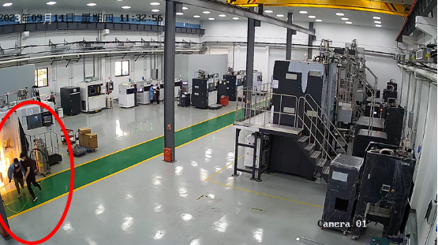
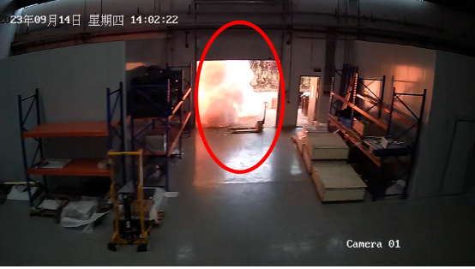
- At 14:02, a second deflagration occurred in the canister dust collector when the operator threw water on the canister dust collector cartridge.
Figure 1 First detonation
Figure 2 Second detonation

Preliminary analysis of the causes of the accident
- The first explosion: before replacing the cartridge dust collector filter element, the operator of the cartridge "wet" treatment, the tap water sprayed into the cartridge and dust collection barrel, water and aluminium alloy dust contact with the exothermic reaction generates hydrogen, due to the small size of the dust collection barrel, the barrel of the cumulative hydrogen concentration of high, in the operation of the operator to collect the barrel dismantling operation, due to static electricity When the operator dismantles the dust collection bucket, it will cause local deflagration in the dust collection bucket due to static electricity or mechanical impact.
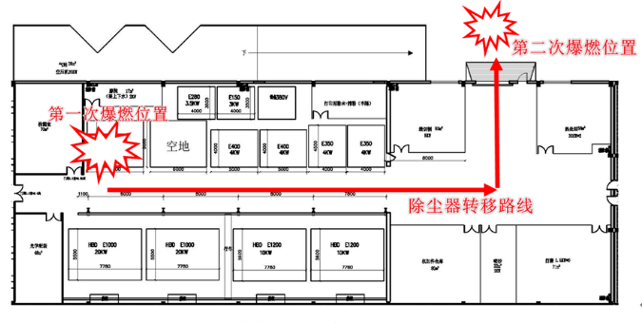
- The second explosion: after opening the door of the box, the suspected operators found that there is a high temperature smoke phenomenon in the area of the cartridge, and then the operators directly to the cartridge to splash water, in the high-temperature conditions quickly caused by the reaction out of control, triggering spontaneous combustion of dust and eruption, leading to the box in the body of the deflagration, resulting in burns to the surrounding employees.
Figure 3 Workshop Division and Ignition Location
Analysis:
Aluminium powder and water reaction to release hydrogen will also produce heat, when the amount of water is sufficient, the heat can be dissipated in time, will not cause heat accumulation; but in the semi-dry and semi-wet state, due to the poor thermal conductivity, the reaction of the heat released is easy to be accumulated in the aluminium powder heap, resulting in the phenomenon of rising temperature, the higher the temperature, the more intense the reaction between aluminium powder and water, the more heat accumulated, which will often lead to the spontaneous combustion of aluminium powder.

What is a dust explosion
Five elements of a dust explosion
- Flammable gases: A certain oxygen content is the basis for dust combustion.
- Combustible dust: Dust that can burn by oxidising with combustion gases.
- Ignition source: A high-temperature heat source that causes a sudden increase in the temperature of a local dust cloud to burn.
- Dust cloud: a cloud of combustible dust suspended in the air and reaching the lower explosive limit.
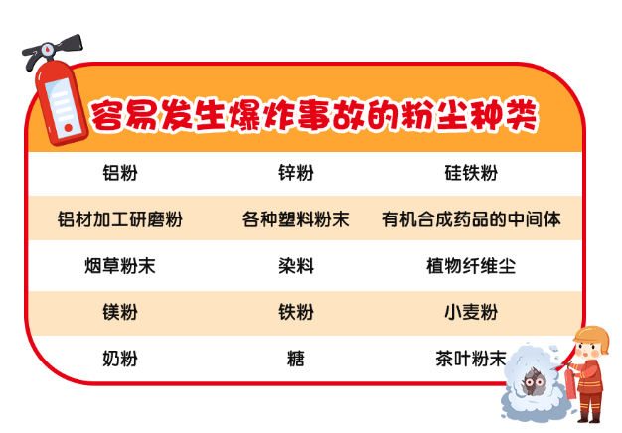
- Confined space: the dust cloud is confined to a relatively airtight space.

Characteristics of a dust explosion
Multiple explosions are the most important feature of dust explosions.
The first explosion of the air wave, will be deposited in the equipment or the dust on the ground will be blown up, in a short period of time after the explosion in the centre of the explosion will form a negative pressure, the surrounding fresh air will be filled from the outside to the inside in, and the raised dust mixed, thus triggering a secondary explosion. Secondary explosion, the dust concentration will be higher.

How to prevent dust explosion
National Safety Standard Committee dust explosion prevention sub-technical committee members, Shanghai Chemical Industry Research Institute, director of the Safety Engineering Centre, Xiao Qiuping, aluminium alloy powder in metal 3D printing is a relatively common raw material, and most of the use of micron-grade aluminium powder, itself flammable, in contact with water reaction can release flammable gas (hydrogen).
Explosion mechanism is mainly: aluminium powder and water reaction to release hydrogen at the same time will also produce heat, when the amount of water is sufficient, the heat can be dissipated in a timely manner, will not cause the accumulation of heat; but in the semi-dry and semi-wet state, due to poor thermal conductivity, the reaction of the heat released in the pile of aluminium powder can easily be accumulated, resulting in the phenomenon of elevated temperatures, and the higher the temperature, aluminium powder and the reaction of the water the more intense the more heat is accumulated, often will be lead to the spontaneous combustion of aluminium powder. In addition, in the metal 3D printing process, there is also a high risk of dust explosion, due to the use of aluminium powder particle size is very small, the possibility of dust explosion and the consequences of the explosion are relatively high.
The following protective measures are recommended for these ignition and explosion risks:
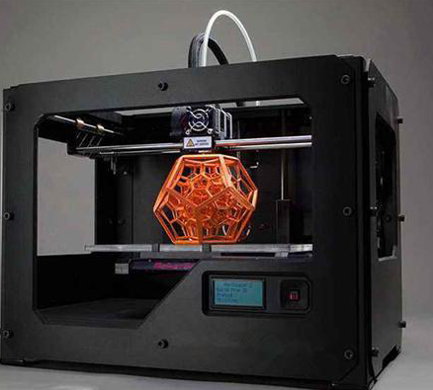
First, strengthening process risk control. It is recommended that metal 3D printing and its filtration process adopt inert gas protection and real-time monitoring of oxygen concentration data to ensure that the relevant process operates under low oxygen concentration, so as to avoid combustion and explosion accidents in the manufacturing process.
Secondly, clean up and dispose of waste powders in a timely manner. When cleaning and disposing of waste powder after production, the use of water for localised "wetting" of confined spaces, such as filters and dust collection drums, should be avoided; if large quantities of water are used to soak and dispose of waste powder, this should be done in an open space in order to prevent the accumulation of hydrogen gas.
Third, strengthening emergency disposal. When aluminium powder catches fire during the production or disposal process, sand can be used to cover the fire when the fire is light, and the extinguishing process should avoid raising dust; when there are no conditions for extinguishing the fire, and the equipment involved in the fire can be moved away to a safe area, it can be allowed to burn on its own; it is strictly prohibited to use water or foam extinguishing agent to extinguish the fire, so as to avoid the consequences of the accident from being amplified.

Nothing we do is worth getting hurt for !

appendice
Criteria for the Determination of Major Accident Hazards in Industrial and Trade Enterprises
Article XI of the existence of dust explosion risk of industrial and trade enterprises in one of the following circumstances, should be judged as a major accident potential hazards:
(a) Dust explosion hazardous places are set up in non-framework multi-storey buildings (structures), or dust explosion hazardous places are equipped with staff dormitories, meeting rooms, offices, rest rooms and other places where people gather;
(ii) different categories of combustible dust, combustible dust and combustible gases and other media easily exacerbated by the risk of explosion share a set of dust removal system, or different buildings (structures), different fire protection zones share a set of dust removal system, dust removal system interconnection;
(c) dry dusting system does not take explosion relief, inerting, explosion suppression and any other explosion prevention and control measures;
(d) Aluminium and magnesium and other metal dust removal system using positive pressure dust removal, or other combustible dust removal system using positive pressure blowing dust, not to take spark detection and elimination and other measures to prevent ignition sources;
(e) Dust removal systems that use gravity settling chambers for dust removal, or dry alley-type structures as dust removal ducts;
(f) Aluminium and magnesium and other metal dust, wood dust dry dust removal system is not set up to lock the air unloading device;
(vii) dust collector, dust collection silo, etc. is divided into 20 areas of the dust explosion hazardous areas of electrical equipment does not meet the explosion-proof requirements;
(viii) crushing, grinding, granulation and other easy to produce mechanical ignition source before the process equipment, not set up iron, stone and other debris removal devices, or wood products processing enterprises and sanding machine connected to the air ducts are not set up to eliminate the spark detection device;
(ix) The collection, stockpiling or storage of metal dust in the event of spontaneous combustion in the presence of moisture without taking measures to prevent the accumulation of hydrogen, such as ventilation, or the dry collection, stockpiling or storage of metal dust without taking measures to prevent waterproofing or moisture;
(j) Failure to implement a dust clean-up system, resulting in serious accumulation of dust at the work site.
:: Source: Ministry of Emergency Management

