Lesson Learn
Safety Knowledge Sharing | January 2024
I. Description of the case
Case I:
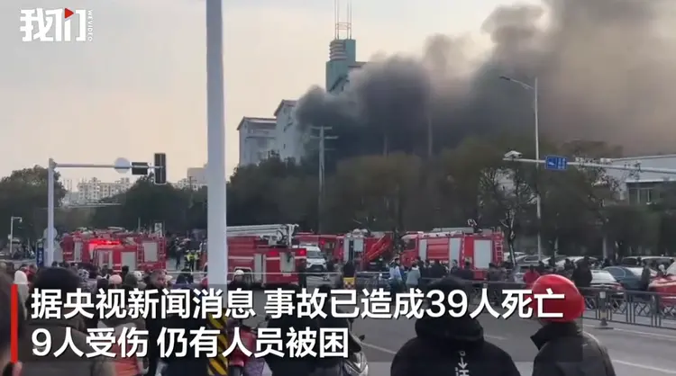
At around 15:00 on January 24, 2024, a fire broke out in a street store in Yushui District, Xinyu City, Jiangxi Province. As of press time, the accident had killed 39 people and injured nine others.
It is understood that the fire building for the six-storey commercial and residential integrated brick structure building, the fire part in the negative floor, and quickly spread to the first floor, the second floor of the commercial stores. After preliminary investigation, the building's first floor is being renovated cold storage, due to construction workers illegal fire construction caused by the fire!
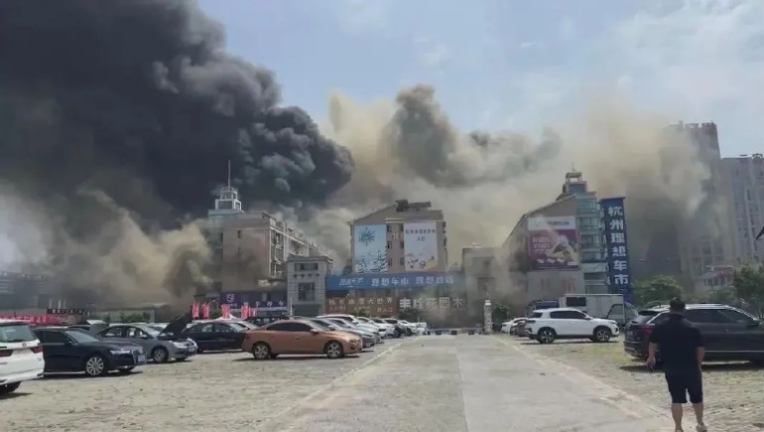
Case II:
June 9, 2022, Zhejiang Hangzhou Ice World construction site workers unauthorized welding cutting operations, slag ignited pipeline insulation debris and decorative materials, the accident caused four deaths, two firefighters sacrificed, 19 people were injured, the building fire area of 600 square meters, the direct economic loss of more than 30.57 million yuan.
Incident III:
On November 21, 2022, a fire broke out in Henan Province's Anyang City Kaixinda Trading Co. The accident caused a total of 42 deaths. After investigation, the accident was caused by the illegal operation of the enterprise personnel and the fire was triggered by electric welding .
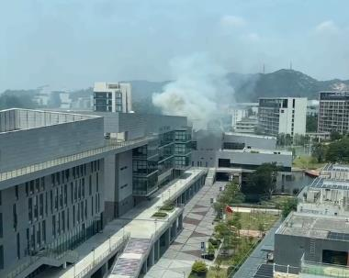
Incident IV:
On May 11, 2023, an incipient fire occurred in our domestic garbage room and the emergency personnel involved responded quickly to extinguish the fire in a timely manner without causing any damage.

II. Analysis of events
Many accidents often stem from a careless operation, in order to figure a moment block, and ignore important information. A simple information labeling can help us avoid many unnecessary risks.
Root Cause:
- non-compliance
Other reasons:
- Combustibles were not cleared in a timely manner.
- Failure to have proper and effective fire extinguishing equipment.
III. Relevant laws and regulations
- Article 21 of the Fire Services Law of the People's Republic of China stipulates that, where the use of open flames is required for construction or other special circumstances, prior authorization procedures shall be carried out in accordance with the regulations and appropriate fire safety measures shall be taken; and operators shall comply with fire safety regulations.
- Personnel performing fire hazardous operations such as welding, gas welding, etc. and the operation of automatic fire protection systems must be licensed and comply with the regulations on fire safety operations.
- Article 63 of the Fire Services Law of the People's Republic of China stipulates that anyone who violates the regulations on the use of open flames or who smokes or uses open flames in places where there is a risk of fire or explosion may be given a warning or fined not more than 500 yuan, or, in serious cases, may be sentenced to detention for not more than five days.
- Article 64 of the Fire Services Law of the People's Republic of China provides that any person who instructs or forces another person to violate fire safety regulations and work at risk shall be sentenced to detention of not less than ten days and not more than fifteen days, and may be fined not more than five hundred yuan; if the circumstances are less serious, the person shall be warned or fined not more than five hundred yuan.

- What to do.
- Implementing the safety responsibility system at each level
Strict safety management of construction sites, the implementation of the safety responsibility system at each level, a clear division of labor and responsibilities, strengthen the examination of construction operators entering the site, and strictly keep a good pass on safety measures.
- Welding operations are strictly prohibited in places of business
It is prohibited to carry out welding, gas welding, gas cutting, wheel cutting, painting and other construction and maintenance operations with fire hazards in places where people are operating or using.
- Operators must be licensed
The construction unit must use the national official training and examination qualified pyrotechnic operators, and welding and cutting of the operational items to be consistent with the qualifications of their special types of work license.
- Clear combustibles before operation
Before operation, move the surrounding combustible materials to a safe place, if it is impossible to move, use non-combustible materials to cover the seal.
- Equipped with fire extinguishing equipment
On-site welding, cutting, baking or heating and other fire operations should be equipped with fire extinguishing equipment, and should set up a fire guardian.
- Thoroughly eliminate fires at the end of operations
Immediately after the end of the construction work to eliminate the fire, thoroughly clean up the work site, and for a period of time to monitor, no problem before leaving the scene, so as to leave no hidden danger.

Always keep in mind: refuse to take chances and don't be afraid of trouble.
Nothing we do is worth getting hurt for !

